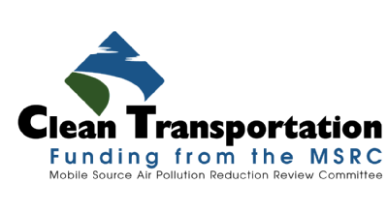
MAjor Event Center Transportation Programs

“Air Quality Improvements through Automobile Trip Reduction & Roadway Congestion Mitigation”

Funding for the Implementation of New or Expanded Public Transportation Programs for Event Center Destinations Located in the South Coast Air Quality Management District

2017-2018 Edition

Program Announcement

PA2017-05

March 3, 2017

SECTION 1 - INTRODUCTION

There are numerous Major Event Centers located within the South Coast Air Quality Management District jurisdiction – these include sports arenas, fairgrounds, stadiums, race tracks, speedways, Convention Centers, etc. Compared to other destination centers such as shopping malls, event centers are utilized on a less frequent, and more importantly, less consistent basis. In the case of sports venues, the arena or stadium is used frequently during the regular season, but sits relatively idle during the offseason.
However, when a ball game, NASCAR race, or other high profile, high attendance event is scheduled at a major event center, the impacts on surrounding communities are usually much more disruptive as compared to other destination centers. As drivers, we have all experienced the traffic impacts created prior to and following an event at a major venue. Surface streets surrounding the event center are impacted by traffic volumes that greatly exceed capacity, freeways are impacted at off-ramps, and vehicle queues extend at signalized intersections to the point where gridlock ensues.
While we understand and even anticipate the extreme traffic congestion that accompanies special events, we often forget that gridlock also has a significant impact on air quality. Vehicles that inch along in stop and go traffic or idle for extended periods burn excessive amounts of fuel and emit excessive levels of air pollutants. The impacts extend well beyond the vehicles that actually attend the event center – traffic impacts can extend for many miles surrounding the event center and impact streets, major arterials, and freeways.
An effective strategy to reduce traffic congestion and its associated air quality impacts, not to mention driver frustration and stress, is to utilize public transportation in lieu of driving to the event. Given these benefits, many newer event centers are located adjacent to regularly scheduled bus, shuttle, or rail service. Event center patrons who take advantage of public transportation are typically spared the aggravation associated with event center parking lot congestion, avoid excessive parking fees and, whether they realize it or not, are doing something beneficial for the environment by not driving their car.
The MSRC, however, is aware that not all major event centers within the South Coast AQMD jurisdiction are served by regularly scheduled transit service. In some cases, the regularly scheduled service that is provided does not match the spike in demand that occurs before and particularly after an event, and therefore requires schedules and service levels to be adjusted to meet the event schedule.
The purpose of this Program Announcement is to identify opportunities to reduce automobile trips, traffic congestion, and their associated air pollutant emissions by shifting attendees of major event center functions out of their personal automobile and onto public transportation. The goal is to align major event centers with transit providers to create a transportation option for event attendees as an alternative to their personal automobile. A shift from automobile to transit benefits not only those who take advantage of the service, but also the communities where the event center is located. The air pollution reduction benefits achieved through automobile trip reduction and congestion relief benefit all residents of the South Coast AQMD.
To facilitate implementation of new or expanded public transportation programs that facilitate use of transportation services to major event centers, the Mobile Source Air Pollution Reduction Review Committee (MSRC) has allocated a total of $5.0M in Clean Transportation Funding™. This funding opportunity has at its core the following goals and objectives:
- Seek out major event center venues located within the South Coast AQMD jurisdiction that experience high levels of traffic congestion during scheduled events and are not served by, or are insufficiently served by, regular public transit services;
- Partner with transit providers and event center venues to develop and implement new or expanded programs to attract patrons to transit services that are tailored to each venue’s scheduled events;
- Encourage transit providers and event center venues to establish ongoing relationships to continue event-specific transit service beyond the MSRC funding period, including the identification of funding sources in addition to the MSRC to support future transportation services.

The MSRC has offered funding for implementation of Event Center Transportation programs for the past several years. This Event Center Transportation Program funding opportunity spans two fiscal years – FY 2017 and FY 2018. This is intended to provide additional flexibility in the development and implementation of event center transportation projects.

To reduce the need to photocopy, package, and physically submit paper applications, the FY 2017-‘18 Edition of the Major Event Center Transportation Program requires that applications be submitted electronically in PDF format using the MSRC Website. We believe this benefits the applicant, the MSRC staff, and the environment.

While many of the features of the previous programs are retained in this funding opportunity, several major changes should be noted:
- All events receiving MSRC Clean Transportation Funding™ under this Program Announcement must be held no later than December 31, 2019.
- Applicants are eligible to propose a maximum of two (2) consecutive event “seasons”, wherein a “season” consists of multiple events or an event that spans multiple days.
- All bus and shuttle vehicles performing Event Center transportation services under this Program must be equipped with an engine that is certified at - or cleaner than – the EPA 2010 emissions standards and certified as such by the California Air Resources Board. All fuels and technologies certified to the 2010 emissions standards are acceptable.
- Applicants that commit to utilize zero-emission or near-zero emission technologies are eligible to receive a higher match. For the purpose of this Program Announcement, “zero-emission” vehicles have zero tailpipe emissions. “Near-zero” technologies have certified NOx emission rates equal to or less than 0.02 grams per brake horsepower-hour (g/bhp-hr) or 0.08 gram per mile.
- For projects that propose expanded rail service, the MSRC requires that Tier 4 locomotives be used for all events beginning January 1, 2018. Tier 4 locomotives must also be used, if available, prior to January 1, 2018. Tier 2 locomotives can be used in support of event center transportation only in the event Tier 4 locomotives are not available and in no case beyond December 31, 2017.

The following Sections describe the eligibility requirements to participate in the MSRC Major Event Center Transportation Services Program, limits on the amount of Clean Transportation Funding™ available to Program participants, and guidelines for proposal preparation. It is important to recognize that the MSRC must ensure that the use of Clean Transportation funds will result in direct, tangible, and quantifiable air quality benefits. To this end, this Program Announcement stipulates specific performance thresholds and participation obligations that must be met in order to be deemed eligible for an MSRC funding award. Projects submitted for funding consideration will be scrutinized to ensure they meet the minimum eligibility requirements described herein. It is likely that some event center transportation proposals will be deemed ineligible or to offer insufficient benefits and will not receive an MSRC funding award.
MSRC staff members are available to answer questions and provide technical and programmatic guidance as appropriate. Please refer to Section 6 of this document for a list of MSRC Staff contacts.

Available Funding - The amount of FY 2017-‘18 MSRC Clean Transportation Funding™ allocated for the Major Event Center Transportation Program is $5.0M. This funding level is a targeted amount – should meritorious projects be received totaling greater than $5.0M, the MSRC reserves the right to increase the amount of total funding available.
Also, should the MSRC receive proposals with total requests less than the amount allocated, or if proposals are deemed non-meritorious, the MSRC reserves the right to reduce the total funding available and reallocate funds to other Work Program categories. The MSRC also reserves the right to not fund any of the proposals received, irrespective of the merits of the proposals submitted.
Please note that the source of MSRC Clean Transportation Funding™ for projects submitted in response to this solicitation is motor vehicle registration fees collected by the California Department of Motor Vehicles (DMV) in accordance with the California Health and Safety Code. Thus, the availability of MSRC Clean Transportation Funding™ is contingent upon the timely receipt of funds from the DMV. Neither the MSRC nor South Coast AQMD can guarantee the collection or remittance of registration fees by the DMV.

SECTION 2 – ELIGIBILITY REQUIREMENTS

This Program Announcement seeks to facilitate the reduction of automobile trips and mitigate traffic congestion by shifting event attendees out of their personal automobile and onto public transportation at major event centers that are not currently served by adequate, regularly scheduled transit or shuttle service prior to, during, and following the venue’s events.
For the purpose of this Program Announcement, the following eligibility requirements apply:
- Major Event Center – a Major Event Center is defined as a publicly or privately-owned, publicly accessible venue located within the geographical jurisdiction of the South Coast Air Quality Management District that possesses the following attributes, at a minimum:
  - Occupancy capacity of at least 7,500 people;
  - Average event attendance of at least 5,000 people;
  - Dedicated parking lot or structure co -located with the event center.
- Traffic Impacted Event – A scheduled event held at a Major Event Center that results in recurrent traffic congestion prior to, during, or after the scheduled event whose impact on surrounding roadways, arterials, intersections, or freeways exceeds design capacity;
Only event centers that are Traffic Impacted are eligible to participate in this Program!
- Transportation Provider – includes but is not necessarily limited to a) public transit agencies, including regional and municipal transit agencies and authorities; b) private transit operators, including subcontractor service providers to public transit agencies; and c) paratransit providers and other licensed, private transportation and shuttle providers;
- Qualifying Transportation Vehicles – vehicles proposed for use in Event Center Transportation Services must conform to the following minimum requirements:
Bus and Shuttle Vehicles:
  - All bus and shuttle vehicles performing Event Center transportation services under this Program must be equipped with an engine that is certified at - or cleaner than – the EPA 2010 emissions standards and certified as such by the California Air Resources Board. All fuels and technologies certified to the 2010 emissions standards are acceptable;
  - Applicants that commit to utilize zero-emission or near-zero emission technologies are eligible to receive a higher match as discussed in Section 3, Paragraph 6, “Program Co-Funding Requirements”;
  - Vehicle Seating Capacity – vehicles must have a minimum seated position capacity of twenty-two (22) occupants;
  - Vehicles must meet all Americans with Disabilities Act (ADA), US Department of Transportation (DOT), California Department of Motor Vehicles (DMV), and other applicable regulatory agency requirements.
Rail Service:
  - For projects that propose expanded rail service, the MSRC requires that Tier 4 locomotives be used for all events beginning January 1, 2018. Tier 4 locomotives must also be used, if available, prior to January 1, 2018. Tier 2 locomotives can be used in support of event center transportation only in the event Tier 4 locomotives are not available and in no case beyond December 31, 2017.
- Transportation Deficient – the Event Center must be Transportation Deficient. This is defined as an Event Center that is not served by regularly scheduled public transit or private shuttle service sufficient to entice patrons to attend the event using public transit rather than private automobile, or is served by public and/or private transportation services that are operating at maximum capacity. Please note that this Program Announcement is NOT intended to subsidize ongoing public or private transportation services.

The MSRC seeks the formation of partnerships between traffic-impacted, transportation-deficient major event centers and transportation providers who operate qualifying vehicles. The following Sections define who is eligible to submit a proposal to the MSRC, who is eligible to enter in to a contract for event center transportation services, and what transportation costs are eligible for reimbursement by the MSRC:
- Who can submit a proposal in response to this Program Announcement? Either a qualifying major event center, a qualifying transportation provider, or a County Transportation Commission may respond to this Program Announcement and submit a proposal for MSRC consideration. Proposals may also be submitted from a joint County Transportation Commission/event center/transportation provider partnership. Please note that the following conditions apply:
  - A proposal submitted by qualifying Major Event Centers must identify what Transportation Provider(s) will provide the event center service. The proposal must include a Memorandum of Understanding (MOU) or letter of support between the event center and transportation provider(s) stating their mutual intent to implement and operate event center transit service in accordance with Program requirements in the event the MSRC provides a funding award;
  - A proposal submitted by a qualifying Transportation Provider must identify which Major Event Center(s) will be served in the Program. The proposal must include an MOU or letter of support between the transportation provider and event center(s) stating their mutual intent to implement and operate event center transit service in accordance with Program requirements in the event the MSRC provides a funding award;
  - A proposal submitted by a County Transportation Commission must identify which Major Event Center(s) will be served in the Program and identify what Transportation Provider(s) will provide the event center service. The proposal must include an MOU or letter of support between the County Transportation Commission and transportation provider and/or event center(s) stating their mutual intent to implement and operate event center transit service in accordance with Program requirements in the event the MSRC provides a funding award;
  - A proposal submitted jointly by a County Transportation Commission in partnership with an event center and transportation provider(s) must also include an MOU or letter of support, as above.

- Who is eligible to receive an award of MSRC Clean Transportation Funding™ under this Program Announcement? While either a County Transportation Commission, major event center or qualifying transportation provider are eligible to submit a proposal, only the qualifying transportation provider or County Transportation Commission is eligible to enter into a contract on behalf of the proposed event center transportation service partnership. The rationale for this restriction is that only transportation service costs (including transit program and traffic control costs) are eligible for reimbursement under this Program. Thus, it makes sense that the service provider who incurs direct expenses in providing transportation services be the party to the contract that provides reimbursement. Please note that the MSRC does not enter into three-party agreements.

In summary, major event centers that meet the above eligibility requirements and transportation providers that meet qualifying requirements are eligible to participate in this MSRC Program. Both Event Centers and Transportation Providers are eligible to submit a proposal; however, each party must be identified by name in the proposal, accompanied by a MOU between the named participants. Only the transportation provider can be the MSRC funding recipient and contract signatory.

SECTION 3 - PARTICIPATION GUIDELINES, CONDITIONS & RESTRICTIONS

The following guidelines, requirements, and conditions have been established and apply to all Proposals:

- Program Scope – The primary objective of this Program is to eliminate automobile trips, reduce automobile vehicle miles traveled (VMT), and reduce traffic congestion in the vicinity of a major event center prior to, during, and following an event, resulting in a reduction in air pollutant emissions. Automobile trip reduction and traffic congestion mitigation are achieved by shifting the travel mode of event attendees from their personal automobile and onto new or expanded public transportation service or dedicated shuttle event center feeder service. To facilitate this mode shift, the MSRC will consider proposals for event center transportation services. MSRC Clean Transportation Funding™ is available to co-fund the cost of implementing new or expanded transportation programs. Only direct costs of transportation programs are eligible for reimbursement under this Program. Proposals submitted in response to this Program Announcement must include as named participants the major event center where new or expanded transit or shuttle service will be operated, as well as the transportation provider who will implement the event center transportation program.
- Maximum MSRC Funding Limits– To ensure broad-based participation, the MSRC has established the following maximum funding parameters:
- The maximum total funding award to any entity that provides event center transportation programs under this solicitation shall not exceed 50% of the total Available Funding. The total available funding currently allocated by the MSRC for this Program is $5.0M. Thus, the maximum total funding award for any single transportation service provider is currently set at $2.5M. This maximum funding restriction can be waived by the MSRC in the event the MSRC does not receive meritorious proposals from other bidders that meet or exceed 50% of the total available funds, or if the MSRC allocates additional funds to the Program. The MSRC reserves the right to determine which projects, if any, are deemed meritorious and warrant a Clean Transportation Funding™ award; and
- The maximum funding allocated for transportation programs for any single major event center shall not exceed 30% of the total available funding. Thus, the maximum MSRC funding amount that can be applied to implementing transportation programs at any one event center is currently limited to a maximum of $1,500,000, subject to the MSRC discretionary provisions cited above.
- All events receiving MSRC Clean Transportation Funding™ under this Program Announcement must be held prior to December 31, 2019.
- Applicants are eligible to propose a maximum of two (2) consecutive event “seasons”, wherein a “season” consists of multiple events or an event that spans multiple days.
- Geographical Funding Minimum - The MSRC has established a Geographical Funding Minimum for each county within the SCAQMD. The geographical funding minimum amount has been set at $350,000 per county. This funding set-aside guarantees a minimum level of funding for each county to implement Event Center Transportation projects. At the end of the application submittal period, March 30, 2018, if any county has funds remaining in its geographical minimum, these funds will be made available to qualifying projects from any other county in order of receipt.
- Eligible Uses of MSRC Funds – MSRC funds may be used to offset direct operating costs associated with event center transportation programs. These include transportation operations and traffic control costs as defined below:
- Transportation Operations – Direct costs associated with operations of event center transportation vehicle and/or rail operations subject to the requirements and conditions outlined in Section 2, Eligibility Requirements;
- Event Center Traffic Control/Bus Priority – Costs associated with providing traffic control to provide participating transportation vehicles event center ingress and egress priority may also be proposed as project co-funding. This includes, but is not necessarily limited to: special lane designation for transit vehicles, including cones, lane striping, etc.; traffic control personnel to direct traffic and grant participating vehicles faster entry and exit; designation of areas for drop off and pickup of event center patrons who utilize the transportation service, including directional signage, markings and placards, etc.
- Transportation Programs Advertising, Outreach, Marketing, and Promotion – All event center transportation programs projects that receive an MSRC Clean Transportation Funding™ award must include advertising and promotion of the availability of the service as a project element. This is a mandatory component of any MSRC-funded event center transportation programs project. Advertising and promotion may include, but is not limited to:
- Radio, television, newspaper, or specialty publication advertisements;
- Print materials;
- Materials developed for incorporation into a website, electronic media, etc.;
- Transportation program kickoff events, ribbon cuttings, or news conferences, etc.
- Program Co-Funding Requirements – Major event center projects funded by the MSRC are required to provide project co-funding in an amount no less than 50% of the total project cost, i.e., a “dollar for dollar match of eligible project co-funding to MSRC Clean Transportation Funding™.
- Projects that propose the use of Zero Emission or Near-Zero emission vehicles or engines are eligible to receive a higher MSRC Clean Transportation Funding™ match. Major event center projects that utilize qualifying zero and near-zero emission vehicles are required to provide project co-funding in an amount no less than 25% of the total project cost.
- For transportation fleets that propose a mix of “2010 standard”-compliant vehicles and “zero/near-zero” vehicles, the match requirement bonus will be prorated based on fleet composition. The determination of whether a vehicle meets zero/near-zero eligibility is solely at the discretion of the MSRC.
Eligible project co-funding includes the following:
- Direct Cost Share – Cash, direct labor, and equipment use contributions from the transportation provider may be accounted for as co-funding;
- Fare box Revenue – Fare box revenue collected to augment MSRC-funded transportation program may be documented and applied as co-funding;
- Transportation Programs Outreach, Marketing, and Promotion – Costs associated with advertising the availability of event center transportation programs may be applied as co-funding. Appropriate outreach may include, but is not limited to, radio, television, newspaper, or specialty publication advertisements, printed materials, materials developed for incorporation into a website, electronic media, transportation program kickoff events, ribbon cuttings, or news conferences, etc.
- Event Center Traffic Control/Bus Priority – Costs associated with providing traffic control to provide participating transportation vehicles event center ingress and egress priority may also be proposed as project co-funding.

- Funding Restrictions – MSRC funds may only be applied to direct operating costs associated with event center transportation programs. These include transportation operations and traffic control costs only. MSRC funds cannot be used:
- To fund capital acquisition costs associated with transportation vehicle purchase;
- To recoup lost parking lot revenue.

- MSRC Funds Remitted on a Reimbursement Basis - MSRC funds will be distributed on a reimbursement basis only upon completion of approved project milestones and submission of all required reports and invoices.

- Additional Conditions on MSRC Funding
- MSRC projects are funded on a “site-specific” basis; that is, each project is evaluated with respect to the proposed event center’s unique location, traffic congestion, availability of other transportation options, etc. Thus, proposals that result in an award of MSRC funds are not allowed to change the event center venue under any circumstances. In the event the proposed venue becomes unavailable, nonviable, or no longer cost-effective, either contract negotiations will terminate or the contract will terminate, as applicable;
- Project Proposers are expected to provide a project implementation schedule as an element of their Proposal. In the event a Proposal is awarded MSRC funds resulting in a contract, the proposed project implementation schedule will become an element of the contract. In the event a contractor is unable to meet project milestones and requires additional time, the MSRC reserves the right to administratively authorize a one-time extension to the period of performance, not to exceed an additional one (1) year. No additional extensions to the contract period of performance will be granted;
- All projects must include an advertising, marketing, and outreach component. Acceptable outreach strategies are described in the previous section;
- Conflict of Interest – Proposers must identify possible conflicts of interest with other clients affected by actions performed by the firm on behalf of the MSRC. Although the bidder will not be automatically disqualified by reason of work performed for such firms, the MSRC reserves the right to consider the nature and extent of such work in evaluating the proposal.

- Certifications – All Proposers must complete and submit the included Attachment G forms as an element of their Proposal (unless specifically exempted below):
- Internal Revenue Service Form W-9 – Request for Taxpayer Identification Number and Certification, and Franchise Tax Board Form 590 – Withholding Exemption Certificate. If you are selected for an award, you cannot be established as a vendor without this information.
- Campaign Contributions Disclosure. This information must be provided at the time of application in accordance with California law. You may be asked for an update when awards are considered.
- MSRC Prospective Contractor Information. This information is needed to help determine if any financial interests exist under the Government Code or other California law. For purposes of this form, the entity which would enter into a contract with SCAQMD is the Contractor.
- Disadvantaged Business Certification. The SCAQMD needs this information for their vendor database. It will not be considered in the determination of your MSRC funding award. Governmental entities do not need to complete this form.
- Finally, in accordance with state law, all projects awarded MSRC Clean Transportation Funding™ are subject to audit. The provisions of the audit are discussed in the Sample Contact, included as Section 9 of this Program Announcement. It is highly recommended that bidders employ government accepted accounting practices when administering their MSRC co-funded project.

SECTION 4 – PROGRAM ANNOUNCEMENT TIMETABLE
The MSRC understands that developing an event center transportation programs project is a complex undertaking. The MSRC also appreciates that events scheduled at a major venue are firm; thus, the MSRC Program is designed to afford potential proposers as much flexibility as possible to allow development of outstanding event center transportation projects. To that end, the MSRC has established an approximately one-year window to prepare and submit proposals for funding consideration.
Table 4-1 - Key Event Center Transportation Programs Program Dates
Program Event | Date
Program Announcement Release | March 3, 2017
Application Submittal Period | March 3, 2017 – March 30, 2018
Latest Date/Time for Electronic Application Submittal | March 30, 2018 @ 11:59 p.m.

SECTION 5 - Proposal Preparation & submittal instructions

An Event Center Transportation Project Proposal must be completed and submitted for funding consideration under this Program. Proposals must be prepared and submitted in accordance with the instructions outlined below.

- Proposal Preparation – The following information must be included in all Proposals seeking MSRC Clean Transportation Funding™ under the Major Event Center Transportation Programs Program:

- Attachments A-G - Proposals must include the following completed Attachments, including all required supporting documentation as requested. Proposal Templates and Instructions are included in Section 8 of this Program Announcement:
- Attachment A: Proposer and Project Participant Information
- Attachment B: Project Description
- Attachment C: Project Cost Breakdown
- Attachment D: Project Implementation Schedule
- Attachment E: Memorandum of Understanding/letter of support between Event Center(s) and Transportation Services Provider(s) (as applicable)
- Attachment F: Transportation Service Ridership Estimates
- Attachment G: Certifications

- Electronic Application Submittal Process – To reduce the need to photocopy, package, and physically submit paper applications, the FY 2017-’18 Major Event Center Transportation Program requires that applications be submitted electronically in PDF format using the MSRC Website. We believe this benefits the applicant, the MSRC staff, and the environment.

The application that will be submitted as a PDF document is comprised of seven (7) primary sections – these correspond to the application Attachments A-G as described in the preceding section. Thus, a complete application will be comprised of the following elements:

- Attachment A: Proposer and Project Participant Information
- Attachment B: Project Description
- Attachment C: Project Cost Breakdown
- Attachment D: Project Implementation Schedule
- Attachment E: Memorandum of Understanding/letter of support between Event Center(s) and Transportation Services Provider(s) (as applicable)
- Attachment F: Transportation Service Ridership Estimates
- Attachment G: Certifications
  - W-9 Form and Form 590
  - Disadvantaged Business Certification Form
  - MSRC Prospective Contractor Information
  - Campaign Contribution Disclosure Form
These seven sections, including Attachment G certifications, are to be compiled into a single PDF document for submittal to the MSRC Clean Transportation Funding Website. Please note that ONLY PDF format can be accepted. Microsoft Word documents cannot be accepted by the MSRC Website. Applicants will need to register on the MSRC Clean Transportation Funding website.

Please note that the latest date and time to submit an application is March 30, 2018 at 11:59 pm!
- Addenda – The Mobile Source Air Pollution Reduction Review Committee may modify the Program Announcement and/or issue supplementary information or guidelines relating to the Program Announcement during the Proposal preparation and acceptance period of March 3, 2017 to March 30, 2018. Amendments will be posted on the MSRC website at www.cleantransportationfunding.org.
- Proposal Modifications - Once submitted, Proposals cannot be altered without the prior written consent of the Mobile Source Air Pollution Reduction Review Committee.
5. Certificates of Insurance - Upon notification of an MSRC funding award, a certificate(s) of insurance naming the South Coast Air Quality Management District (SCAQMD) as an additional insured will be required within forty-five (45) days. Entities that are self-insured will be required to provide proof of self-insurance prior to contract execution.
SECTION 6 - IF YOU NEED HELP…
This Program Announcement can be obtained by accessing the MSRC web site at www.cleantransportationfunding.org. MSRC staff members are available to answer questions during the Proposal acceptance period. In order to help expedite assistance, please direct your inquiries to the applicable staff person, as follows:

- For General or Technical Assistance, please contact:
Ray Gorski
MSRC Technical Advisor
Phone: 909-396-2479
E-mail: Ray@CleanTransportationFunding.org

- For Administrative Assistance, please contact:
Cynthia Ravenstein
MSRC Contracts Administrator
Phone: 909-396-3269
E-mail: Cynthia@CleanTransportationFunding.org

- For Contractual Assistance, please contact:
Dean Hughbanks
SCAQMD Procurement Manager
Phone: 909-396-2808
E-mail: dhughbanks@aqmd.gov

sECTION 7- Proposal Evaluation and Approval Process
Proposals will be screened upon receipt by MSRC staff members to determine compliance with all mandatory requirements. Proposals deemed compliant will be forwarded to an Evaluation Subcommittee comprised of members of the MSRC Technical Advisory Committee (MSRC-TAC). Proposals will be evaluated in order of receipt using criteria established by the MSRC; these criteria are listed below. Proposals will be recommended for funding based upon their perceived conformance with the established criteria and in accordance with the maximum funding provisions stipulated in Section 3.3 of this Program Announcement. Please note that the MSRC reserves the right to make funding awards upon determination that a proposed event center transportation program is meritorious. As such, it is possible that all funding allocated to this Program could be fully expended prior to the close of the proposal submittal period, March 30, 2018.
Evaluation Criteria – Factors to be used when assessing the merits of a proposed event center transportation project are outlined below. Each project will be assessed individually against the evaluation criteria. A maximum of 100 points is available – projects that receive less than 60 points will not be eligible for an MSRC funding award.

- POTENTIAL TO ACHIEVE QUANTIFIABLE AIR POLLUTANT REDUCTIONS (0 - 75 Points). Each project will be analyzed to estimate its potential to achieve motor vehicle air pollution reductions, emphasizing reductions in oxides of nitrogen and particulate matter pollution. Factors to be evaluated include, but are not limited to:
- The types, quantity, emissions profile, and proposed utilization of the vehicles proposed to implement the event center transportation services;
- Event center transportation service ridership estimates based on previous documented event center project results, surveys or focus groups conducted to estimate potential transportation service utilization, etc.;
- The event center location, population density, and location relative to major arterial roadways and freeways;
- Availability of existing transportation options other than personal automobile;
- The number of events scheduled or planned for the event center during the proposed period of program;
- The average venue attendance;
- The proposed fare; and
- The ability to integrate the proposed transportation program with other existing public transportation services. This includes potential connectivity with existing bus line, rail lines, etc. Connectivity with regional or municipal bus service, Metrolink, light rail, transit centers, park and ride lots, etc. will be evaluated.

- ADDITIONAL PROJECT CO-FUNDING (0 - 10 Points). Projects that exceed the minimum co-funding requirements specified in Section 3, Paragraph 6 will receive up to 10 points based upon the following schedule:
Vehicle Type Providing Service | 5 points | 10 points
Meets minimum requirements | ≥ 55% co-funding | ≥ 75% co-funding
Meets optional emission standards | ≥ 30% co-funding | ≥ 50% co-funding

- PROGRAM CONTINUATION PLAN (0 – 15 Points). The potential for extending event center transportation programs beyond the MSRC-funded period will be assessed. Projects that have a definitive plan for continuing transportation programs beyond the initial MSRC funding period will be awarded a higher point allocation.
Proposals deemed meritorious by the MSRC-TAC will be forwarded to the MSRC for evaluation, review, and potential funding approval. Please note that the MSRC retains full discretion and authority as it pertains to a potential award of Clean Transportation Funding™. The decision to award funding, or not award funding, will be based on the proposed project’s potential to achieve direct and tangible emission reductions. Thus, it is anticipated that not all projects submitted for funding consideration will receive an MSRC award.

SECTION 8 - Proposal ATTACHMENTS – PA2017-05

Attachment A: Proposal CONTACT Information

- Please provide the following Proposer information in the space provided (This is information about the entity submitting the proposal):
Business Name
Division of:
Subsidiary of:
Website Address
Type of Business  Check One: | - Individual  - DBA, Name _______________, County Filed in _______________  - Corporation, ID No. ________________  - LLC/LLP, ID No. _______________  - Other _______________

Address
City
State |  | Zip
Phone | ( ) - Ext | Fax | ( ) -
Contact Name |  | Title
E-mail Address
Payment Name if Different

- Funding Request Summary:
MSRC Clean Transportation Funding™ Requested: $____________________
Other Co-Funding Applied to Project: $____________________
Total Project Cost: $____________________

- Please provide the following information about the Event Center in the space provided below:
Event Center Name
Website Address
Type of Venue

Address
City
State |  | Zip
Phone | ( ) - Ext | Fax | ( ) -
Venue Contact Name |  | Title
E-mail Address
Payment Name if Different

- Please provide the following information about the Transportation Service Provider in the space provided (If this information was provided in Section 8.A, simply type “See Above”):
Business Name
Division of:
Subsidiary of:
Website Address
Type of Business

Address
City/Town
State/Province |  | Zip
Phone | ( ) - Ext | Fax | ( ) -
Contact Name |  | Title
E-mail Address
Payment Name if Different

Attachment B: project Description

- Event Center Description - Please provide a detailed description of the major event center. At a minimum, provide the following information:
- General Characteristics of the Event Center, including type of venue, facility physical size, occupancy capacity, parking lot capacity, etc.;
- Average number of events held annually or during a full season of operation;
- Average attendance at a regularly scheduled event; peak attendance at special events;
- Traffic conditions in proximity to event center prior to, during, and following a regularly scheduled event. If possible, provide a statement from the City or County Traffic Engineering Department verifying that traffic volumes on adjacent roadways and intersections prior to and following a scheduled event exceed roadway and intersection capacity.
- Proposed Transportation Program Description – Provide a detailed description of the proposed event center transportation program. This should include, at a minimum:
- A description of the vehicles proposed to perform transportation services, including the make and model, model year, engine model and year, alternative fuel type if required, seating positions, and total capacity (seated and standing) for each vehicle proposed to be utilized in event center transportation services.
- The estimated number of events for which transportation program will be implemented. Include event schedules, dates, etc. to the extent feasible.
- A description of how the transportation program services will be conducted, including passenger pickup locations, passenger drop-off locations, anticipated headways, hours of operation, etc.
- For circulator-type transportation services, please include a map of the vehicle route(s) that graphically illustrates vehicle routing, passenger pickup and drop-off locations, etc.
- Connectivity with Other Public Transit Service - Please discuss potential connectivity with other public transit services, including but not limited to potential connectivity with existing regional or municipal bus lines, Metrolink, light rail, transit centers, park and ride lots, etc.
- Advertising, Marketing, Outreach, and Promotion of Event Center Transportation Program – Please describe the plan for conducting outreach and promotion of the availability of event center transportation programs. This may include, but is not limited to, radio, television, newspaper, or specialty publication advertisements; other printed materials; materials developed for incorporation into a website, electronic media, etc., transportation program kickoff events, ribbon cuttings, or news conferences, etc. Please note that outreach and promotion is a mandatory element of any event center transportation program project funded by the MSRC and may be accounted for as an in-kind co-funding contribution.
- Program Continuation Plan – Please describe what efforts will be made by the event center/transportation provider partnership to secure necessary resources to continue event center transportation program beyond the initial MSRC funding period.

Attachment C: Cost Breakdown: Please provide a detailed cost breakdown of the proposed project. Please note that MSRC Clean Transportation Funding™ is intended to help offset the cost of transportation program, and cannot be applied to capital equipment purchases or used to offset lost parking facility revenues. The MSRC reserves the right to exclude cost elements deemed unallowable, as well as award funding in an amount less than the requested amount.

Attachment D: PROJECT IMPLEMENTATION SCHEDULE

Please provide a Milestone Schedule for your proposed event center transportation program project. This should include, at a minimum, the anticipated date event center transportation program will commence, as well as any additional information regarding scheduled events to be supported by transportation services.

Attachment E: Memorandum of Understanding/Letter of support Between transportation service provider (proposed Contractor) and event center Site
For projects seeking MSRC Clean Transportation Funding™ for implementation or expansion of an event center transportation program, a fully executed Memorandum of Understanding (MOU) or letter of support must be submitted as an element of the proposal package.
The MOU/Letter of Support must be provided at the time of Proposal Submittal and must contain the following essential elements, at a minimum:
- The parties to the MOU/Letter of Support, including the transportation service provider(s) and event center site owner or authorized representative;
- The term of the MOU/Letter of Support;
- The specific location of where transportation services will be provided;
- Anticipated dates of transportation service start of operation and completion;
- Executed signatures by individuals authorized on behalf of the parties to the MOU/Letter of Support.
If the proposal package contains a letter of support, an MOU may be required prior to execution of a contract.
Attachment F: transportation PROGRAM Ridership Estimates
Please provide an estimate of the anticipated utilization of the event center transportation program if implemented as proposed. Please include any empirical information used to generate ridership estimates, including but not limited to survey results, focus group results, etc.
Please note that as a condition of funding award, the contractor will be required to survey, document, or otherwise quantify the patronage of the event center transportation program in order for the MSRC to quantify motor vehicle emission reductions achieved by the transportation program.
Attachment G: CERTIFICATIONS
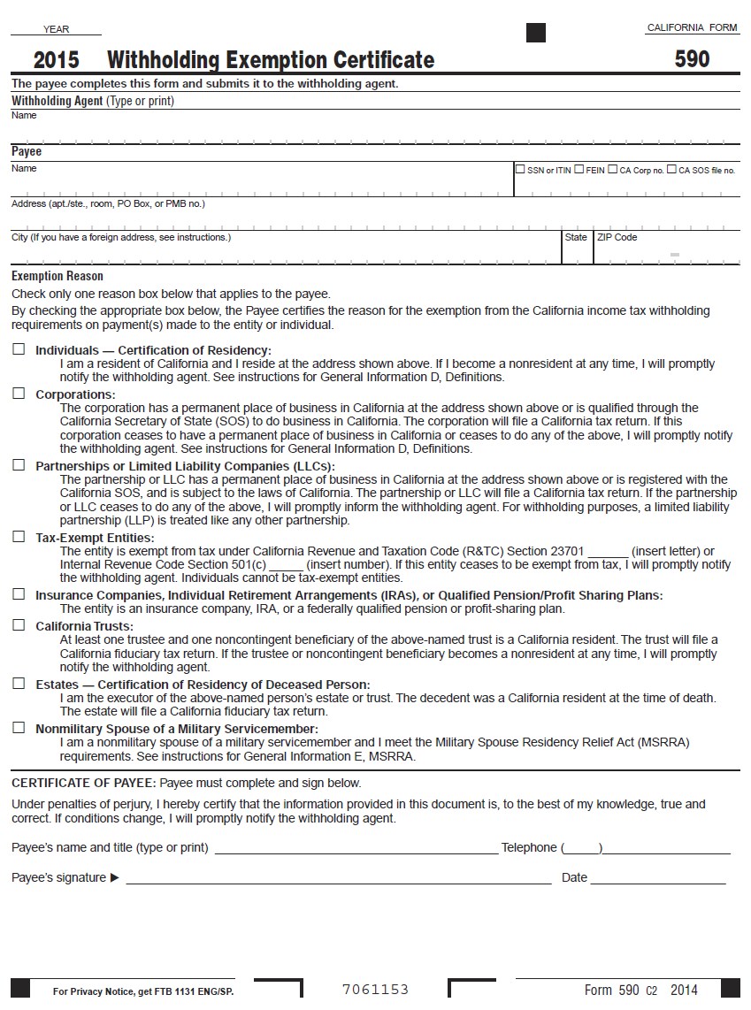
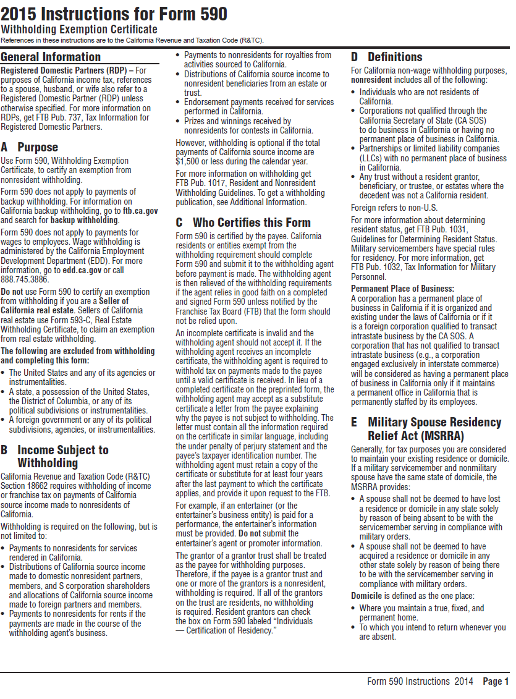
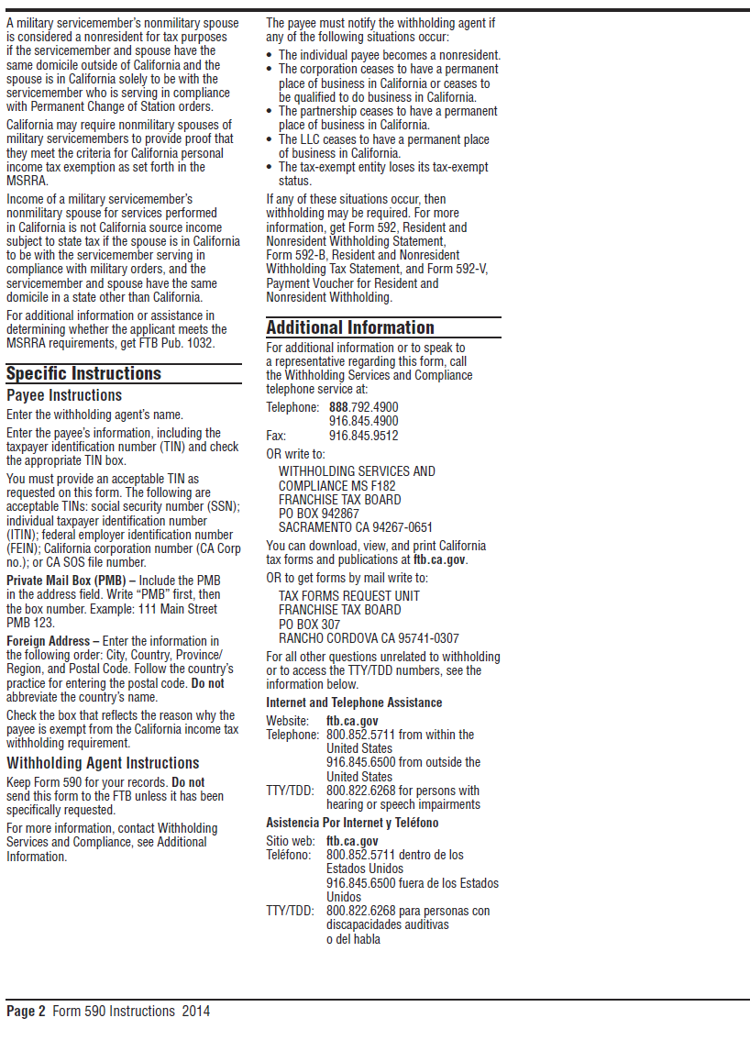

CAMPAIGN CONTRIBUTIONS DISCLOSURE

In accordance with California law, bidders and contracting parties are required to disclose, at the time the application is filed, information relating to any campaign contributions made to South Coast Air Quality Management District (SCAQMD) Board Members or members/alternates of the MSRC, including: the name of the party making the contribution (which includes any parent, subsidiary or otherwise related business entity, as defined below), the amount of the contribution, and the date the contribution was made. 2 C.C.R. §18438.8(b).

California law prohibits a party, or an agent, from making campaign contributions to SCAQMD Governing Board Members or members/alternates of the Mobile Source Air Pollution Reduction Review Committee (MSRC) of more than $250 while their contract or permit is pending before SCAQMD; and further prohibits a campaign contribution from being made for three (3) months following the date of the final decision by the Governing Board or the MSRC on a donor’s contract or permit. Gov’t Code §84308(d). For purposes of reaching the $250 limit, the campaign contributions of the bidder or contractor plus contributions by its parents, affiliates, and related companies of the contractor or bidder are added together. 2 C.C.R. §18438.5.

In addition, SCAQMD Board Members or members/alternates of the MSRC must abstain from voting on a contract or permit if they have received a campaign contribution from a party or participant to the proceeding, or agent, totaling more than $250 in the 12-month period prior to the consideration of the item by the Governing Board or the MSRC. Gov’t Code §84308(c).

The list of current SCAQMD Governing Board Members can be found at SCAQMD website (www.aqmd.gov). The list of current MSRC members/alternates can be found at the MSRC website (http://www.cleantransportationfunding.org).

SECTION I.
Contractor (Legal Name):

DBA, Name , County Filed in
Corporation, ID No.
LLC/LLP, ID No.

List any parent, subsidiaries, or otherwise affiliated business entities of Contractor:
(See definition below).

SECTION II.

Has Contractor and/or any parent, subsidiary, or affiliated company, or agent thereof, made a campaign contribution(s) totaling $250 or more in the aggregate to a current member of the South Coast Air Quality Management Governing Board or member/alternate of the MSRC in the 12 months preceding the date of execution of this disclosure?

Yes No If YES, complete Section II below and then sign and date the form.
If NO, sign and date below. Include this form with your submittal.

Campaign Contributions Disclosure, continued:

Name of Contributor

Governing Board Member or MSRC Member/Alternate Amount of Contribution Date of Contribution

Name of Contributor

Governing Board Member or MSRC Member/Alternate Amount of Contribution Date of Contribution

Name of Contributor

Governing Board Member or MSRC Member/Alternate Amount of Contribution Date of Contribution

Name of Contributor

Governing Board Member or MSRC Member/Alternate Amount of Contribution Date of Contribution

I declare the foregoing disclosures to be true and correct.

By:

Title:

Date:

DEFINITIONS

Parent, Subsidiary, or Otherwise Related Business Entity (2 Cal. Code of Regs., §18703.1(d).)

(1) Parent subsidiary. A parent subsidiary relationship exists when one corporation directly or indirectly owns shares possessing more than 50 percent of the voting power of another corporation.

(2) Otherwise related business entity. Business entities, including corporations, partnerships, joint ventures and any other organizations and enterprises operated for profit, which do not have a parent subsidiary relationship are otherwise related if any one of the following three tests is met:
(A) One business entity has a controlling ownership interest in the other business entity.
(B) There is shared management and control between the entities. In determining whether there is shared management and control, consideration should be given to the following factors:
- The same person or substantially the same person owns and manages the two entities;
- There are common or commingled funds or assets;
- The business entities share the use of the same offices or employees, or otherwise share activities, resources or personnel on a regular basis;
- There is otherwise a regular and close working relationship between the entities; or
(C) A controlling owner (50% or greater interest as a shareholder or as a general partner) in one entity also is a controlling owner in the other entity.

MSRC Prospective Contractor Information
- Contractor (Legal Name): __________________________________________________

- Brief Description of Project: ________________________________________________
- Did Contractor retain a consultant to help prepare the funding application?
Yes No If YES, identify consultant below and then sign and date the form. If NO, sign and date below.
Name of Consultant _____________________________

I declare the foregoing disclosure to be true and correct.
Name: _____________________________

Signature: _______________________

Title: _______________________

Date: _______________________

DISADVANTAGED BUSINESS CERTIFICATION

Federal guidance for utilization of disadvantaged business enterprises allows a vendor to be deemed a small business enterprise (SBE), minority
business enterprise (MBE) or women business enterprise (WBE) if it meets the criteria below.
- is certified by the Small Business Administration or
- is certified by a state or federal agency or
- is an independent MBE(s) or WBE(s) business concern which is at least 51 percent owned and controlled by minority group member(s) who are citizens of the United States.

Statements of certification:

As a prime contractor to the SCAQMD, (name of business) will engage in good faith efforts to achieve the fair share in accordance with 40 CFR Section 33.301, and will follow the six affirmative steps listed below for contracts or purchase orders funded in whole or in part by federal grants and contracts.

- Place qualified SBEs, MBEs, and WBEs on solicitation lists.
- Assure that SBEs, MBEs, and WBEs are solicited whenever possible.
- When economically feasible, divide total requirements into small tasks or quantities to permit greater participation by SBEs, MBEs, and WBEs.
- Establish delivery schedules, if possible, to encourage participation by SBEs, MBEs, and WBEs.
- Use services of Small Business Administration, Minority Business Development Agency of the Department of Commerce, and/or any agency authorized as a clearinghouse for SBEs, MBEs, and WBEs.
- If subcontracts are to be let, take the above affirmative steps.

Self-Certification Verification: Also for use in awarding additional points, as applicable, in accordance with SCAQMD Procurement Policy and Procedure:

Check all that apply:

Small Business Enterprise/Small Business Joint Venture Women-owned Business Enterprise
Local business Disabled Veteran-owned Business Enterprise/DVBE Joint Venture
Minority-owned Business Enterprise

Percent of ownership: %

Name of Qualifying Owner(s):

State of California Public Works Contractor Registration No. ______________________. MUST BE INCLUDED IF BID PROPOSAL IS FOR PUBLIC WORKS PROJECT.

I, the undersigned, hereby declare that to the best of my knowledge the above information is accurate. Upon penalty of perjury, I certify information submitted is factual.

NAME TITLE

- TELEPHONE NUMBER DATE

Definitions

Disabled Veteran-Owned Business Enterprise means a business that meets all of the following criteria:
- is a sole proprietorship or partnership of which is at least 51 percent owned by one or more disabled veterans, or in the case of any business whose stock is publicly held, at least 51 percent of the stock is owned by one or more disabled veterans; a subsidiary which is wholly owned by a parent corporation but only if at least 51 percent of the voting stock of the parent corporation is owned by one or more disabled veterans; or a joint venture in which at least 51 percent of the joint venture’s management and control and earnings are held by one or more disabled veterans.
- the management and control of the daily business operations are by one or more disabled veterans. The disabled veterans who exercise management and control are not required to be the same disabled veterans as the owners of the business.
- is a sole proprietorship, corporation, partnership, or joint venture with its primary headquarters office located in the United States and which is not a branch or subsidiary of a foreign corporation, firm, or other foreign-based business.

Joint Venture means that one party to the joint venture is a DVBE and owns at least 51 percent of the joint venture. In the case of a joint venture formed for a single project this means that DVBE will receive at least 51 percent of the project dollars.

Local Business means a business that meets all of the following criteria:

- has an ongoing business within the boundary of the SCAQMD at the time of bid application.
- performs 90 percent of the work within SCAQMD’s jurisdiction.

Minority-Owned Business Enterprise means a business that meets all of the following criteria:

- is at least 51 percent owned by one or more minority persons or in the case of any business whose stock is publicly held, at least 51 percent of the stock is owned by one or more minority persons.
- is a business whose management and daily business operations are controlled or owned by one or more minority person.
- is a business which is a sole proprietorship, corporation, partnership, joint venture, an association, or a cooperative with its primary headquarters office located in the United States, which is not a branch or subsidiary of a foreign corporation, foreign firm, or other foreign business.

“Minority” person means a Black American, Hispanic American, Native American (including American Indian, Eskimo, Aleut, and Native Hawaiian), Asian-Indian American (including a person whose origins are from India, Pakistan, or Bangladesh), Asian-Pacific American (including a person whose origins are from Japan, China, the Philippines, Vietnam, Korea, Samoa, Guam, the United States Trust Territories of the Pacific, Northern Marianas, Laos, Cambodia, or Taiwan).

Small Business Enterprise means a business that meets the following criteria:

- 1) an independently owned and operated business; 2) not dominant in its field of operation; 3) together with affiliates is either:

- A service, construction, or non-manufacturer with 100 or fewer employees, and average annual gross receipts of ten million dollars ($10,000,000) or less over the previous three years, or

- A manufacturer with 100 or fewer employees.

- Manufacturer means a business that is both of the following:

- Primarily engaged in the chemical or mechanical transformation of raw materials or processed substances into new products.

- Classified between Codes 311000 to 339000, inclusive, of the North American Industrial Classification System (NAICS) Manual published by the United States Office of Management and Budget, 2007 edition.

Small Business Joint Venture means that one party to the joint venture is a Small Business and owns at least 51 percent of the joint venture. In the case of a joint venture formed for a single project this means that the Small Business will receive at least 51 percent of the project dollars.

Women-Owned Business Enterprise means a business that meets all of the following criteria:

- is at least 51 percent owned by one or more women or in the case of any business whose stock is publicly held, at least 51 percent of the stock is owned by one or more women.
- is a business whose management and daily business operations are controlled or owned by one or more women.
- is a business which is a sole proprietorship, corporation, partnership, or a joint venture, with its primary headquarters office located in the United States, which is not a branch or subsidiary of a foreign corporation, foreign firm, or other foreign business.

2010 emission standards require NOx emissions less than or equal to 0.2 g/bhp-hr and particulate matter emissions less than or equal to 0.01 g/bhp-hr.
For the purpose of this Program Announcement, “zero-emission” vehicles have zero tailpipe emissions. “Near-zero” technologies have certified NOx emission rates equal to or less than 0.02 grams per brake horsepower-hour (g/bhp-hr) or 0.08 gram per mile.

